Training Analysis - Manual
- Activity Detail Pages
  - Training Analysis Activity Detail Page
    - Tab "Performance Indices"
    - Tab "Critical Power"
    - Tab "Histogram"
    - Tab "Correlation"
    - Tab "Other Tracks"
    - Tab "Lactate"
    - Zone Tables
    - Line Charts
- Settings Pages
  - Training Analysis Plugin
    - Plugin Information
    - Donation Wallet
- Miscellenaous
  - Documentation Components for the Activity Documentation Plugin
  - Report Fields for the Activity Documentation Plugin
  - Map Highlighting in conjunction with the Map Overlay Plugin
- Glossary
  - Critical Power
  - Intensity Factor (IF)
  - Rating of Perceived Exertion (RPE)
  - Recovery Heartrate
  - Resting Heartrate
  - Threshold Power
  - TRaining IMPulses (TRIMP)
  - Training Stress Score (TSS)
- Further Reading

Activity Detail Pages

Training Analysis Activity Detail Page
This is where all tools provided by this plugin can be found.
The page consists of several tabs that provide the different tools:
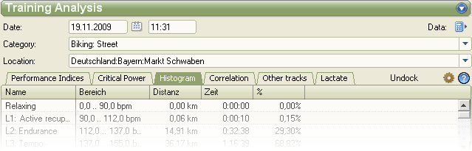
Simply click on the tab headers to switch tools.
There are a few common controls at the very right of the tab headers:
- click on "Undock" to undock this view from the SportTracks main window; this is handy when you use a multi screen setup or when you want to view the plugin's detail page in parallel with other detail pages
- click on to switch to the plugin settings view
- clic on to open the online manual - the one you're just reading

Tab "Performance Indices"
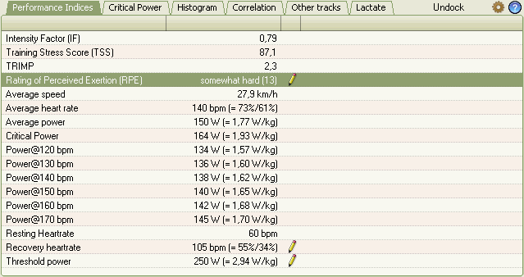
Items that are marked with a are not calculated by the plugin but can be edited by you.
When you click on an editor opens that lets you enter and change the value:
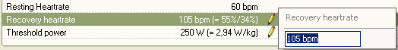
As you can see from the example above, the plugin can express power as absolute values and relative values, i.e. Watt per body weight unit. In order to see this, you must configure your body weight in the SportTracks Athlete view.
Heart rate can as well be expressed in relative terms, i.e. in % of your max heart rate and % of your heart rate reserve. To enable the relative display, configure your max and resting heart rate in the SportTracks Athlete view.
Tooltips are provided for the more complex values.
You don't know exactly what these indices are for? I've provided a brief glossary that should help you understand the different measures and their relevance and benefits. However, I can't explain these in depth in an overview document like this.

Tab "Critical Power"
This tab, as well as the following ones has a common layout:
- a Zone Table on top that
  - show you which times and distances you spent in this zone
  - lets you highlight the corresponding intervals, when you select one or several zones
- a Line Chart that shows you the selected track over distance, over (elapsed) time or over wall time
- a chart that is specific for the particular tab page
Please click here to find an explanation of the zone table, here to learn about the line charts. I've explained this just once, because it works the same on every tab page.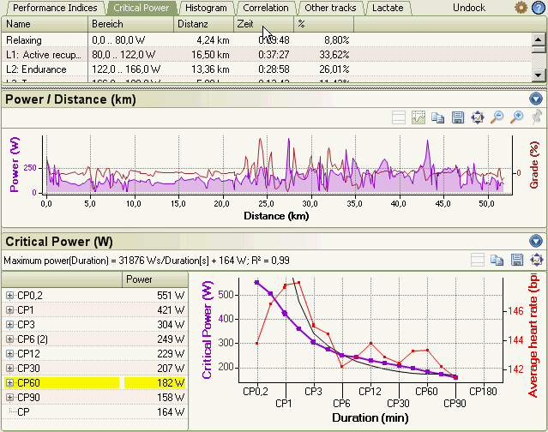
The critical power chart is accompanied by a critical power table to it's left.
What are the "CPn" values in the table and the chart?
It's the maximum power that you have delivered during this activity for a period of n minutes.
So CP0.2 is the highest power over 12 seconds, i.e. a typical sprint or high output interval.
CP180, the longest interval that the plugin considers, is the maximum power over 3 hours.
These values are automatically determined by the plugin and entered into the table and the chart.
What can you see in the chart:
- the violet line is the critical power as explained above
- the red line is your average heart rate during the interval that yielded the max. power for this duration
- the gray line is a calculated one; it's a regression line according to the theory of critical power that provides the best approximation for the violet line
User interaction:
- when you hover the mouse over an item in the table, a tiny tooltip pops up that gives you more information for this entry
- when you click on an item in the table, the corresponding point is selected in the right hand chart, the corresponding time range (12:54:46h .. 13:00:46h in this case, i.e. exactly 6 minutes) is highlighted in the line chart above
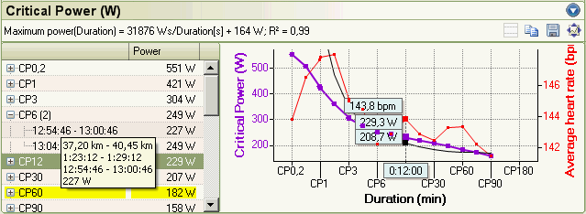
- right click in the table and a context menu opens that provides additional actions
- click on the lines in the chart and see the highlighting change approprately
Note: did you notice that there are in fact two entries for CP6 in the example above - one with 227W and one with 249W. Why that? Well, there might be several n minute intervals that provide a nearly equal power value. I've decided to list all disjoint intervals that provide at least 90% of the power delivered in the most powerful interval.
When you click on the button in the lower right, the main menu of this page opens and lets you select:
- absolute power: to display power in Watts
- relative power: to display power in Watts per kg of your body weight
Please note the buttons just below the menu button . They equal the ones for line charts and are explained there.

Tab "Histogram"
This pages provides a "spectral analysis" of e.g. your heart rate, i.e. how is your heart rate distributed. The "bell curve" in the example below is quite common for a rather flat course with a steady speed. The curves will significantly differ for hilly terrain, where long descents let your heart rate drop while steep ascents let it rise close to max. You'll observe a diagram with highs on both ends a depression in the mid range.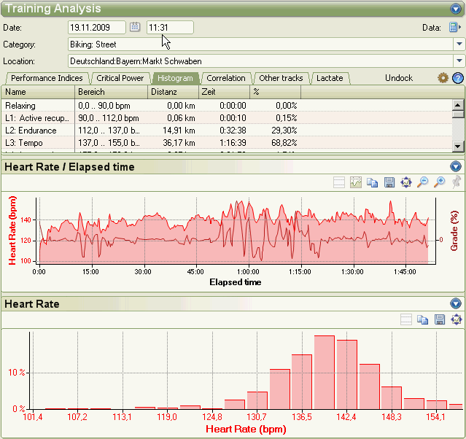
When you click on the button in the lower right, the main menu of this page opens:
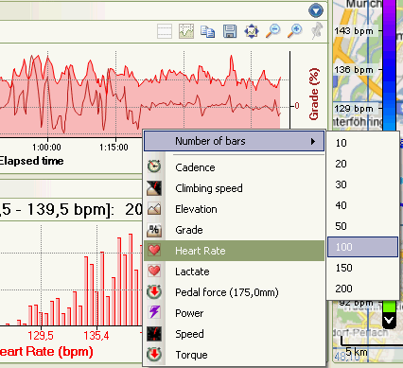
It lets you select the track that you want to analyze and the number of histogram bars - from 10 for a coarse analysis to 200 for a fine grained display.
Please note the buttons just below the menu button . They equal the ones for line charts and are explained there.

Tab "Correlation"
The most complex and maybe the most valuable tool provided by this plugin.
It lets you analyze correlations between two parameters.
The page layout is slightly different: due to the fact that there are two parameters, not just one, the upper part consists of two zone tables, one for the values on the X axis and one for the Y axis:
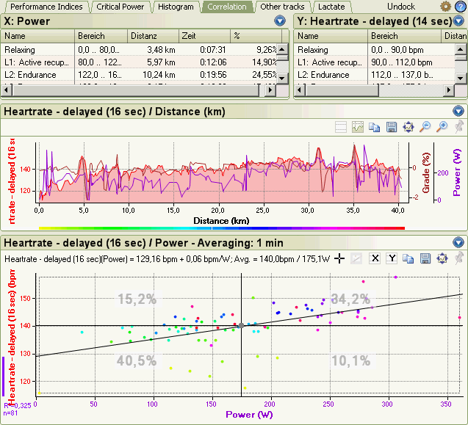
Let's start with the main menu first.
Once again it opens when you click on the menu button in the lower right:
It provides four main entries:
- Standard:
You can select one of the two standard correlations provided by this plugin:
- heart rate vs. power
- pedal force vs. cadence (i.e. quadrant analysis)
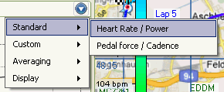
- Custom:
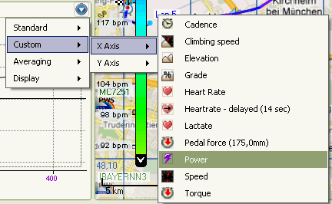
This lets you select whatever you like for the X axis and the Y axis. You think that there might be a correlation of elevation and heart rate? Try it out!
Note: you might have noticed the entry "Heart rate - delayed (14 sec)". What does this mean?
Well, your body is not like your car. When you increase power output, your heart rate doesn't rise instantenously, but with a certain delay. Correlation a momentary power value with the heart rate at the same point of time would be misleading. So in order to improve the correlation, the plugin calculates the delay that provides the best correlation. In the example above the current power value is correlated with the heart rate 14 seconds later.
- Averaging:
Usually it doesn't make sense to draw a correlation point for every value recorded by your bike computer. You would end up with thousands of points for a multi hour exercise.
So the plugin lets you choose and averaging interval (10 seconds to 10 minutes) and averages the values over these intervals, resulting in one point per interval and providing a less cluttered chart.
- Display:
Select "Points" or "Points and Lines".
OK, but what's displayed in the correlation chart:
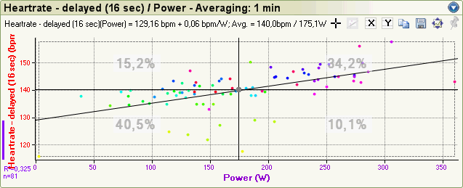
- one point x,y per averaging interval, in this example one point power/heart rate per one minute interval;
the point is color coded according to it's position on the time scale - from yellow over green, blue and purple to red; a corresponding rainbow bar is printed in the line chart.
- two crossed lines, indicating the average values for X and Y axes, 175.1W and 140.0bpm in this example
- a percentage value per quadrant separated by the average lines, indicating how much time you spent in these quadrants
- a regression line, indicating the best linear approximation for the values on the X and Y axes;
note that the formula is printed just above the chart;
in this example it's 129.16bpm + 0.06bpm/W, which means that when idling the heart rate is 129 bpm and every single Watt of additional power output raises your heartrate by 0.06 beats per minute.
- a R² bar in the far left telling you the stability index, i.e. the quality of the linear approximation;
0 means "no correlation at all, an arbitrary cloud of points"
1 means "perfect linear correlation, i.e. all points are situated on one exact line"
Note: R²below say 0.2 indicated a rather coarse correlation that you should not consider as valid
The tool bar of the correlation chart provides some buttons that are not present in other charts:
- or : switch to selection mode or dragging mode (what happens when you click the mouse and drag)
- : switch on a filter, i.e. a rectangular area that you can adjust in order to skip points outside of this area
- : with an "x" or a "y" inside: switch on the display of zones for the X resp. Y axis
User interaction:
- click on a point in the chart and a small popup gives you more information for this point:
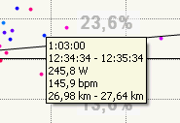
- when in selection mode (see above) click on the chart pane and drag the mouse to select all points in a rectangular area;
selected points will be displayer bigger and they will flash

Tab "Other Tracks"
This tab resembles the different activity detail pages in the SportTracks core application.
This is where you find the "new" tracks that this plugin adds to SportTracks:
- climbing speed
- torque
- pedal force
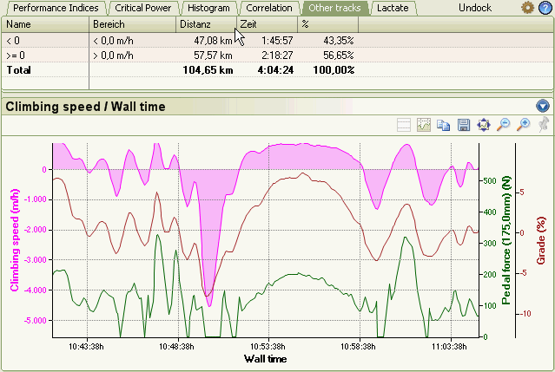
When you click on the button in the lower right, the main menu of this page opens:
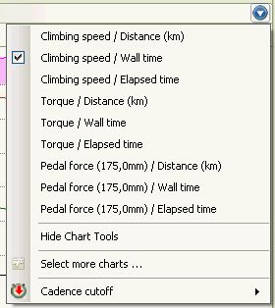
You can choose the desired track and display over distance, wall time or (elapsed) time.
The "Cacence cutoff" entry lets you change the setting for cadence cutoff without having to go to the plugin's settings page.

Tab "Lactate"
Well, this page is for the pros or semi pros among you, those that have their blood lactate tested during fitness tests.
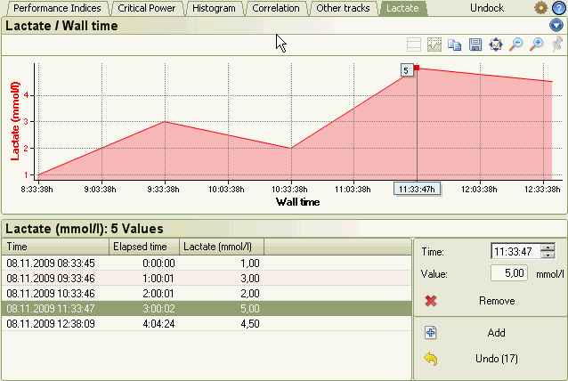
You can enter your lactate values in the editor pane in the lower part of this tab page:
- to add new values, click on "Add" and edit the "Time" and "Value" fields
- to modify existing values, simply select them in the list and change time and/or value
- to remove values, select them in the list and click on "Remove"
When you right click in the list, a context menu opens that lets you:
- copy the list to the Windows clipboard in CSV format and
- paste a CSV file into the editor
So in order to import multiple rows, simply enter one row, copy it into Excel, add more data into the spread sheet and paste these back into the editor.
Note: There's an Undo button; guess what it does.

Zone Tables
These tables are used on most tab pages of this plugin. You already know them from SportTracks' standard activity detail pages, so just a few remarks.
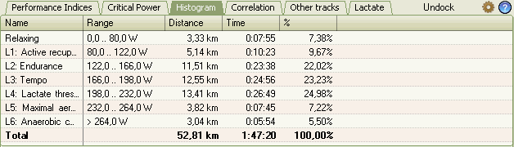
When you select one or many (Shift-Click or Ctrl-Click) items in the table, the charts highlight those ranges, where the parameter is within the selected zone(s).
When you right click in the list, a context menu opens that lets you:
- copy the list to the Windows clipboard
- change the set of columns on display (menu item "List settings ...")
- edit the available zones (menu item "Edit")
Note that the plugin adds zones to SportTracks that are not part of the core functionality:
- elevation zones
- climbing speed zones
- torque zones
- pedal force zones
- lactate zones
When you click Edit for these zones, an editor window opens where you can define the zones. These zones are saved in the logbook file.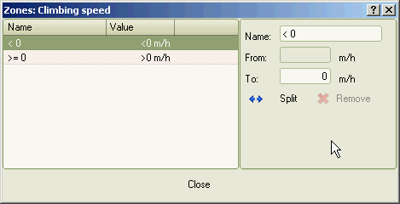

Line Charts
These charts should as well be familiar to you, as they are one of the major elements on SportTracks' standard activity detail pages, so I'll focus on differences.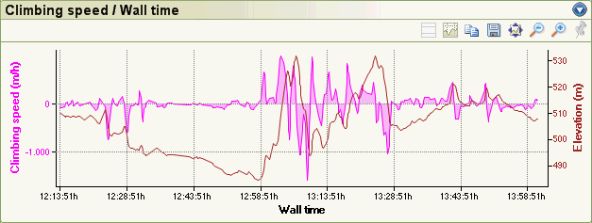
Display over wall time: while ST's standard charts can display over distance or over (elapsed) time, the power analysis plugin can display over wall time as well. This makes a major difference, when there are "stopped" times (i.e. intervals where either your GPS device has paused it's timer or your speed was less than the "stopped" threshold.
Display over (elapsed) time skips these intervals, display over wall time includes them. So when you want to see your stopped intervals, click on the menu button and choose display over wall time.
Additional buttons:
- : very much like the "Save" button, but copies the chart image to the Windows clipboard rather then saving it to a file
- : this lets you lock the value axis ranges.
Click on this button, it changes to . When you then switch activities the value axis ranges are no longer autozoomed to fit all data of the activity. This makes it easier to compare activities when you switch between them.
Note: the selected axis ranges are remembered, so when you close and reopen SportTracks, the axes will be set up to these ranges.

